Marine fenders:

Pictures

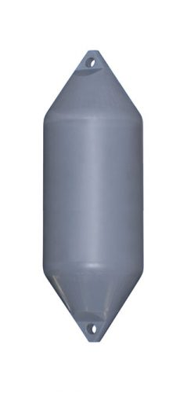

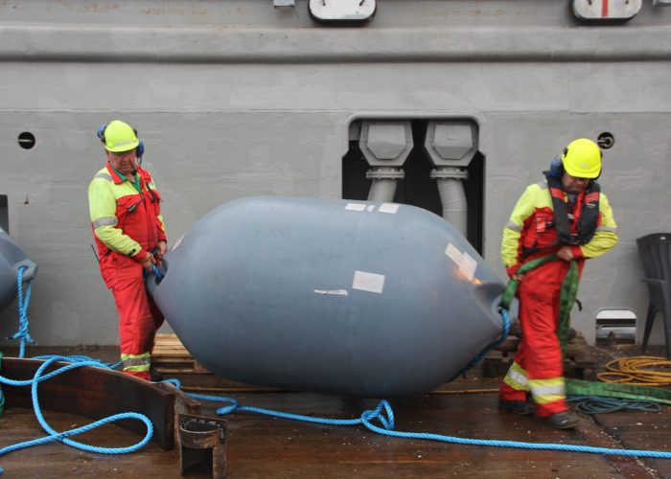

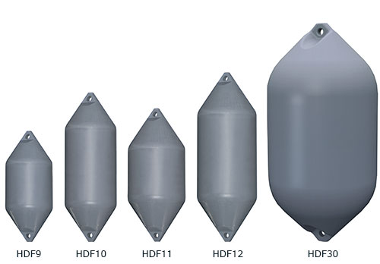

Types:

- Inflatable buoys and fenders

- Rotary molding of a plastic (LDPE type?)
- Can be filled with pur foam

- Foam filled fenders

- EVA Foam, sheaves cut in shaped and glued on top op each other to make the fender. A cylinder inside for fixing the rope etc. Afterwards the foam is coated with poluera (plastic coating)

- Non inflatable hard shell PE fenders

- rotationally molded buoys, pontoon floats and custom made products produced from PE (Polyethylene).
- Buoys for mooring are usually filled with polystyrene foam (EPS) and may also be offered filled with polyurethane foam (PUR).

- Yokohama style:
- rubber vulcanised like a car tyre. Inside air

